**Voice Controlled Home Automation**

**Abstraction:** Nowadays at home, we have a switch ON or OFF any devices means we have to go and turned ON or OFF the switch. But in this project using an android application to turn ON and OFF swatches through Wireless communication via Bluetooth devices, Bluetooth is connected to the microcontroller. Home automation allows us to control household electrical appliances like light, door, fan, AC etc. It also provides home security and emergency system to be activated. Home automation not only refers to reduce human efforts but also energy efficiency and time saving.

**Requirements:**

* **Hardware:** 
  + - Arduino uno,
    - Bluetooth Module (Hc-05),
    - 4-Channel Relay Module,
    - Breadboard,
    - Android phone
    - 220v Bulb, Fan
* **Software:**
  + - Arduino IDE
    - Arduino Bluetooth A.p.k

**Block Diagram:**

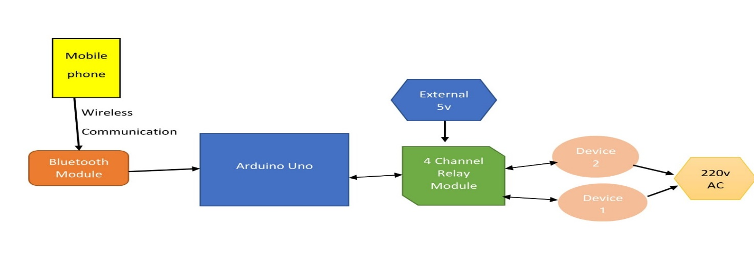

**Working:** In this project, a simple Voice Activated Home Automation system is designed. Voice commands are used to control different appliances. We will now see the working of the project. All the connections are made as per the circuit diagram above.

After making the necessary connections, we have to switch on the power supply to the circuit. Now, we need to pair the Phone’s Bluetooth to the HC – 05 Bluetooth Module. Before that, we have to install the App mentioned above in the phone. The home screen of the app looks something like this.

[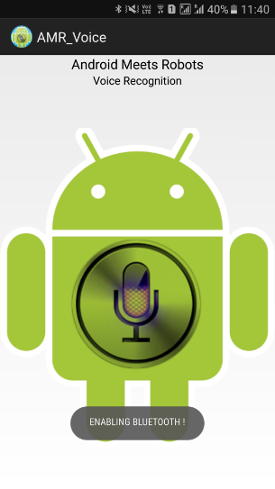](https://www.electronicshub.org/wp-content/uploads/2017/03/Screenshot-1.png)

Next step is to connect the phone with the Bluetooth module. For this, choose the option “Connect Robot” and select the appropriate Bluetooth Device. If the devices aren’t paired earlier, we need to pair them now using the Pin of the HC – 05 Bluetooth Module.

[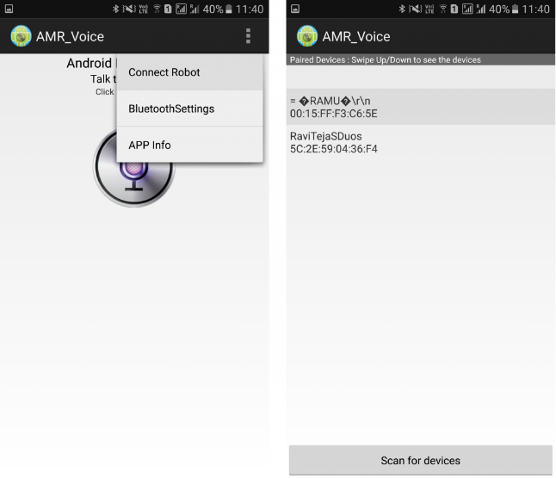](https://www.electronicshub.org/wp-content/uploads/2017/03/Screenshot-2.png)

After successful connection, the devices are ready to transmit data. For that, press the press microphone icon on the app and start giving voice commands.

**NOTE**: Make sure that the voice recognition feature is enabled on the phone (this is usually associated with Google app).

For example, if we press the microphone icon and say “turn on light”, the app will recognize the command and the transfers it to the Bluetooth Module. Also, the command gets displayed on the screen for our reference.

[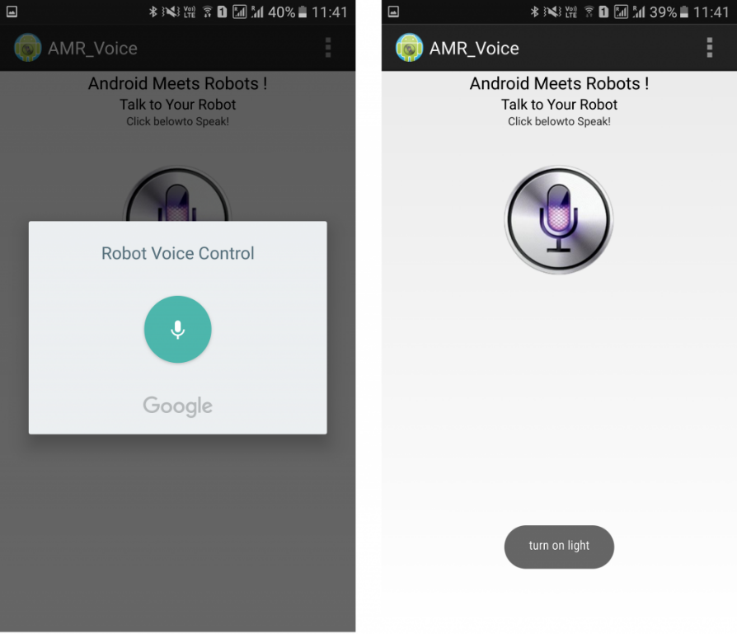](https://www.electronicshub.org/wp-content/uploads/2017/03/Screenshot-3.png)

When the string “turn on light” is detected by the app, it will send the string as “*turn on light#”. So, the actual message received by the Bluetooth Module is in the format of “*Message#”. The reason for padding the ‘*’ and ‘#’ at the begging and end of the string is to identify the starting and ending of the message.

We are able to delete the ‘#’ from the string but left out the ‘*’ in order to identify the starting of the string. The received message is compared with some predefined strings and if the message matches with any of them, then corresponding action like turning on or turning off the load happens.

We have used the following commands: “turn on AC”, “turn off AC”, “turn on light”, “turn off light”, “turn on TV”, “turn off TV”, “turn on fan”, “turn off fan”, “turn on all” and “turn off all”.

### Circuit Design:

We will now see the design of the Voice Activated Home Automation circuit. First, we will connect the Bluetooth Module to the Arduino. Since Bluetooth uses UART protocol, we need to use the RX and TX pins of the Arduino. We will be using “SoftwareSerial” library to define our own RX and TX pins (Pin 2 is RX and Pin 3 is TX).

NOTE: We have left out the Bluetooth’s RX and Arduino’s TX connection as it is not used. In case you face a problem, connect a voltage divider to convert the Arduino TX’s 5V signal to Bluetooth RX’s 3.3V.

Next, we will connect the relays to the Arduino. Since we used a readymade relay board with 4 – channels, all we need to do is to connect the inputs of the individual relays to the Arduino. For detailed connection like the resistor, transistor, diode and relay, refer the circuit diagram.

NOTE: We did not connect any load to the relay but you can always connect some small loads and check out the functioning. Be extra careful while using AC Mains with relay board.

**Applications:**

* The Voice Activated Home Automation system will help us control different loads (electrical appliances) with simple voice commands.
* This kind of system is very useful for people with disabilities.
* Further, the project can be expanded by adding different sensors (light, smoke, etc.).

**Conclusion:** Our implemented module is more reliable and flexible in order to control any loads and the coverage area for ireless control is 10 meters. Hence this project can be useful for a real time voice controlled home automation. Thus arduino based voice controlled home appliances proves to be a better remote controlled operation on home appliances using Bluetooth module HC-05.

This project can be extended for many automation applications such as industrial automation, automotive, military, healthcare, transportation and so on. Further the coverage area can also be increased by the use of GSM modules.